Dinov3 x ConvNeXt Classification Performance Summary

Datasets:
- Apple Tree Leaf Disease Dataset (apple)
- Cassava Leaf Disease Classification Dataset (cassava)
- Corn or Maize Leaf Disease Dataset (corn)
- Rice Leafs Disease Dataset (rice)
- PlantVillage (plant_village)
- PDD_Pretrained
- Agricultural Pests Dataset (agri_pests)
For more information about these datasets, you can read here.

Algorithmn detail:
- Model: Dinov3 (ConvNeXt Large 198M LVD-1689M)
- Augmentations:
According to the dataset descriptions, some datasets need strong augmentations while some need light ones. In the code, we define augmentation policy, so each dataset will get the suitable augmentation policy.
AUG_POLICIES = {
'apple': 'strong',
'cassava': 'strong',
'corn': 'light',
'potato': 'strong',
'rice': 'light',
'plant_village': 'strong',
'PDD_Pretrained': 'strong',
'agricultural_pests': 'strong',
}
If it is strong augmentation, it needs geometry and color augmentations, while geometry ones are enough for light augmentation.
- Process:
  - Load pretrained backbone and initialize the new classification head.
  - Setup optimizer, loss function, and cosine LR scheduler.
  - Training: forward → compute loss → backward → optimizer step (mixed precision).
  - Validate each epoch and track the best checkpoint.
  - Evaluate the best model on the test set to measure generalization.
  - Save training history, metrics, confusion matrix, and model checkpoints.
Performance
Table 1: Test Set Performance Metrics Comparison by datasets
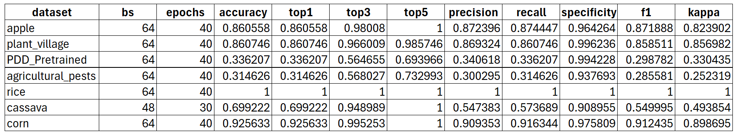
We chose the pairs of batch_size and num_epochs that give the best performance for each dataset. Higher epoch counts or larger batch sizes could not be executed due to GPU memory limitations.
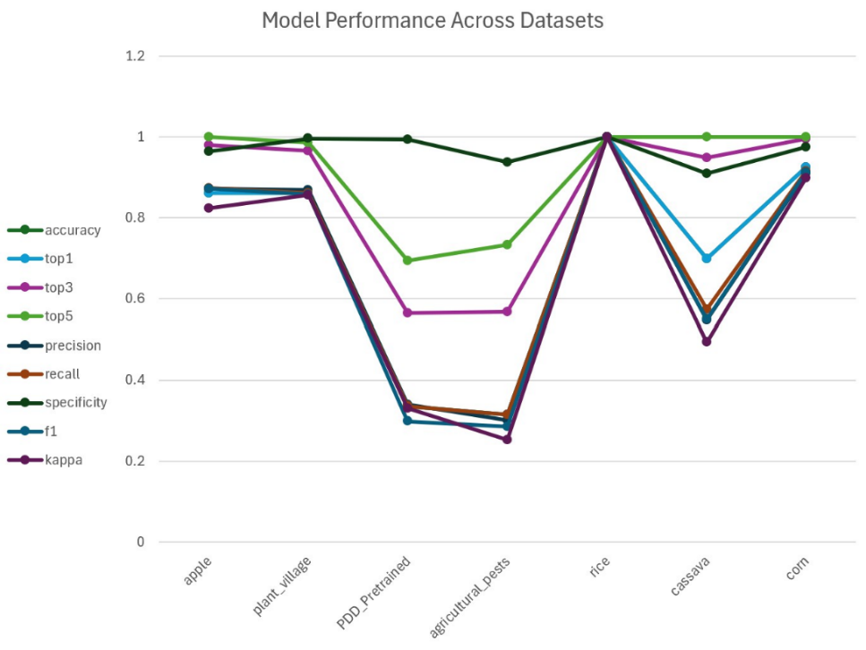
Figure 1: Graph of table 1
Conclusion: The model achieves strong performance on the apple, plant_village, corn, and especially the rice datasets, where all metrics reach near-perfect or perfect levels. In contrast, PDD_Pretrained and agricultural_pests show significantly lower accuracy and F1 scores, indicating higher dataset complexity or domain mismatch. The cassava dataset yields moderate results. Overall, model performance is highly dataset-dependent.
Next Steps (for High-Performing Datasets Only)
Apple Dataset
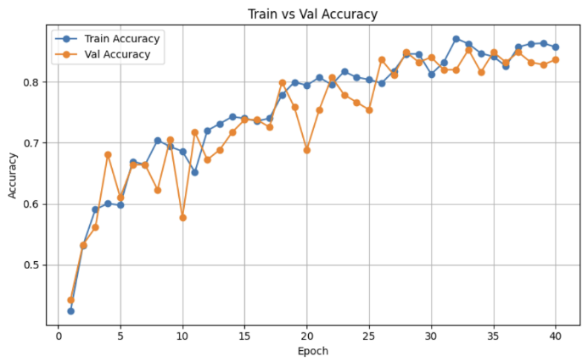
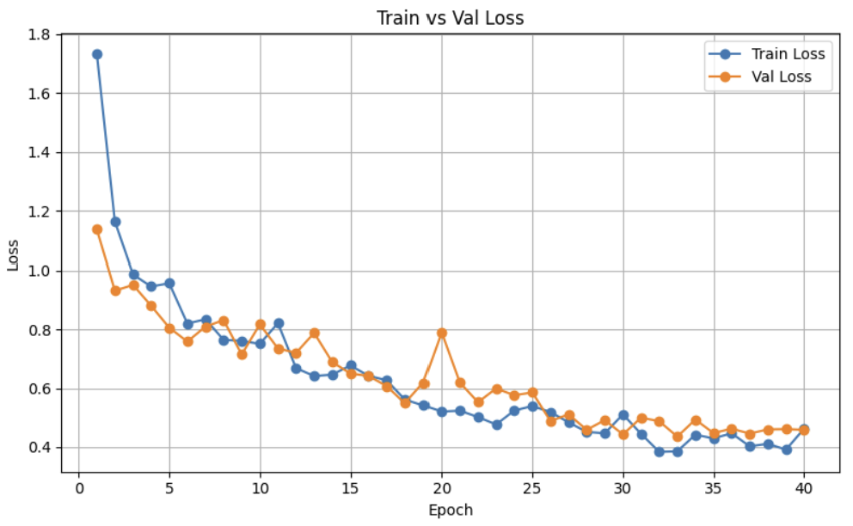
Figure 2 and 3: Performance of model on apple dataset
Observation:
- Overall accuracy are high, but the training curves are not fully smooth.
Possible Improvements:
- Lower learning rate to stabilize optimization.
- Increase batch size if better GPU is available.

Corn, PlantVillage, Rice (Smooth Curves & Strong Performance)
For the well-performing datasets (corn, rice, plant_village), future work should focus on expanding model capability rather than fixing instability. This includes applying explainable AI methods, exploring feature, trying larger configurations, more intensive hyperparameter tuning, and testing more advanced training algorithms. Furthermore, extending the pipeline from detection to segmentation before classification may lead to more robust and interpretable models.

Overall Next Steps Summary
Overall, future work should explore more advanced training strategies, richer feature representations, and extended processing pipelines to further enhance model robustness and generalization across diverse agricultural datasets.

